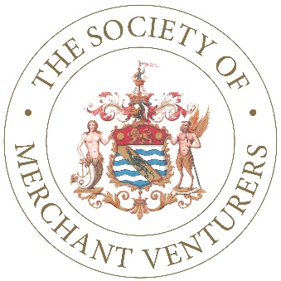
The Society of Merchant Venturers

Operations & Marketing Executive

Salary: £28k to £32k
Location: Clifton, Bristol

Who are we looking for?

Are you a self-starter who can make this role your own but who looks forward to working collaboratively with a close-knit, busy team?

Are you someone who is happy to work on your own but equally keen to support the Treasurer (CEO) on a wide variety of projects?

This is a new role and it requires a blend of high-level operational management skills combined with innovation and research. You will be skilled in Office IT systems including Microsoft 365, desktop publishing and all forms of social media.

This is a hands-on role where you will be meeting a huge range of people and the ability to form effective and trusting relationships quickly will be imperative. Evidence of successful event planning and delivery will be desirable, for up to 100 guests, where attention to detail is crucial. An important responsibility will be leading the activity to market Merchants’ Hall as a venue for functions and events, primarily through advertising, PR and social media.

This position will allow you to bring your own creative flair, with the opportunity to develop the role over time.

Further details about the role and the job description can be found here:
https://www.merchantventurers.com/news/operations-marketing-executive/

About us

The Society of Merchant Venturers (SMV) is working with other organisations and individuals across Greater Bristol that are striving for an inclusive and sustainable society. We are supporting the implementation of the Bristol One City Plan and we routinely collaborate with a wide variety of stakeholders across the region. The role is based at Merchants’ Hall in Clifton, with some scope for flexible working.

SMV is a membership organisation, comprising up to 80 people who share a commitment to improve the wellbeing of communities in Greater Bristol. Established under Royal Charter in 1552, the modern-day Society is ambitious and dynamic.

Our members give their time and skills to support communities across the region through various initiatives related to SMV’s five core areas of activity:

- Education - we are currently educating over 4,000 young people across the city in nine schools at both primary and secondary level.
- Care for Older People - we are supporting the care of over 5,000 older people either directly through our own care homes or indirectly through our work with the St Monica Trust.
- Social Enterprise - we are founding members of Bristol & Bath Regional Capital (BBRC), developed in collaboration with several local universities, local authorities and other organisations. BBRC seeks to raise investment for local social enterprise projects.
- Charitable Giving - we make small grants to local organisations with a focus on helping the most vulnerable and disadvantaged.
- Stewardship of the Downs - we jointly manage and protect the Downs with Bristol City Council for the enjoyment of all residents of Greater Bristol.
How to apply

Please send a full CV and covering letter to cduckworth@merchantventurers.com

The covering letter should be no more than two sides of A4 and should include the following information:

- How you can demonstrate the essential and desirable requirements of the role.
- Details of two referees – one should be your manager in your current or last employment. We will not take up your references without your permission to do so.
- Confirmation of your right to work in the UK.
- Details of your current notice period.

We are committed to increasing the diversity of the SMV team and as such we would also ask you to anonymously complete the equality monitoring form, which can be found here. The form should be submitted separately from your CV and covering letter.

Closing date: Please submit your application no later than midnight on Sunday 9th August.

Interviews: Interviews are likely to take place on Wednesday 19th August. Please advise if you are not available on this date.

Thank you for your interest in joining our team.

