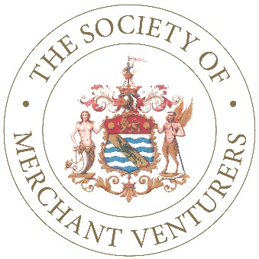

The Society of Merchant Venturers

Operations & Marketing Executive

Job Description:

Role Purpose

To support the Treasurer in leading and managing the operations of the Society of Merchant Venturers (SMV), ensuring optimal delivery of service to members and customers. Organising meetings and events; and supporting the promotion of SMV through marketing and research.

Responsibilities

  - Manage and deliver the administration functions for this small and busy office, improving the office’s efficiency and effectiveness
  - Produce committee meeting papers, research reports and accurate minutes from meetings
  - Liaise with members of the Society
  - Schedule meetings, internally and externally, and oversee general diary management
  - Act as Clerk to some of the small charities under our management
  - Work with the Communications Director to develop and optimise our social media output, increasing our presence on Twitter, LinkedIn and Instagram etc.
  - Lead on the marketing and promotion of Merchants’ Hall for events and manage all bookings
  - Be responsible for the organisation and administration of all SMV functions and events held at Merchants’ Hall
  - Manage one part-time member of administration staff
  - Review and improve the administration functions of the organisation to achieve best practice.

Person specification

Essential

- Highly organised with excellent attention to detail
- Excellent written, presentation and verbal communication skills
- Confident user of social media platforms
- Skilled user of Microsoft 365 (Word, PowerPoint, Excel and Publisher)
- A strong commitment to the charitable aims of SMV
- Commitment to high-quality customer service in all aspects of the role
- Team player with a good sense of humour
- Positive, proactive and professional attitude and approach to work
- Ability to manage your own time, plan and prioritise workload
- Strong commitment to innovation and continuous improvement
- Experience in office management and administrative process improvement
- Experience of meeting management including clerking and production of minutes.

Desirable

- Experience of successful high-quality event management
- Able to produce effective marketing materials under the guidance of the Communications Director
- Able to draft short, well-written case studies for the website
- Able to research detailed topics and produce concise reports
- Experience of managing other team members.

